5th Sept,2018

**Docker: Concepts in Container Technologies**

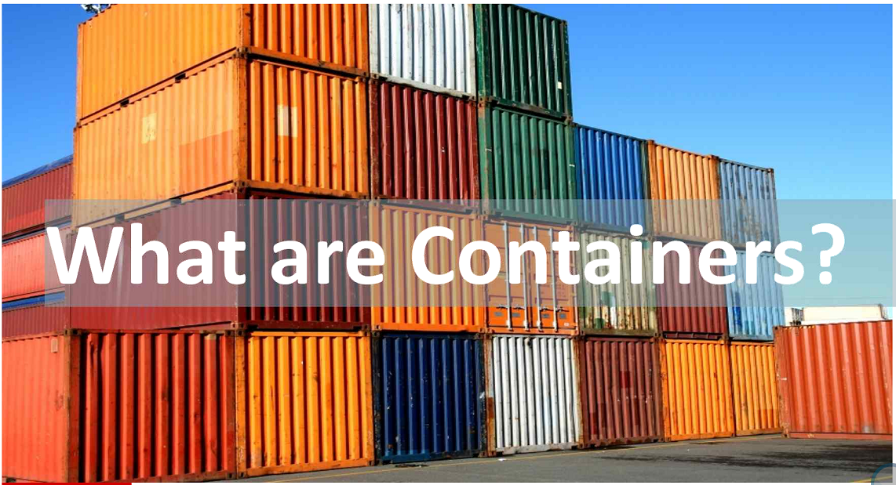

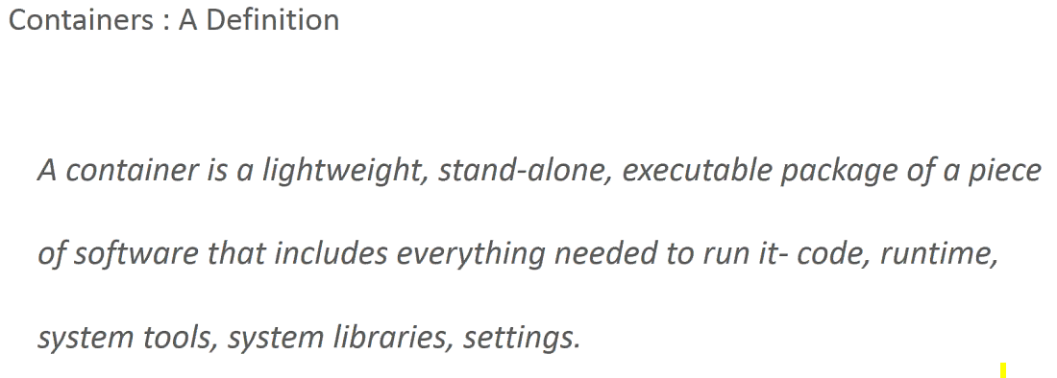

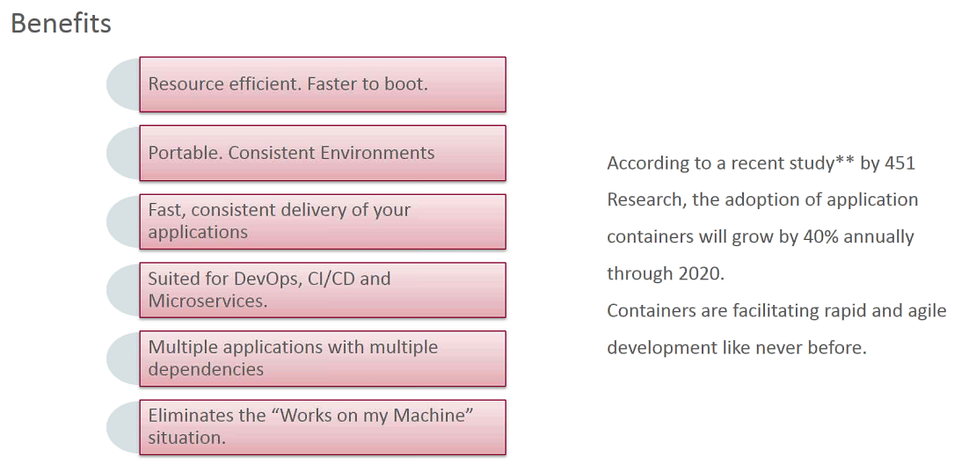

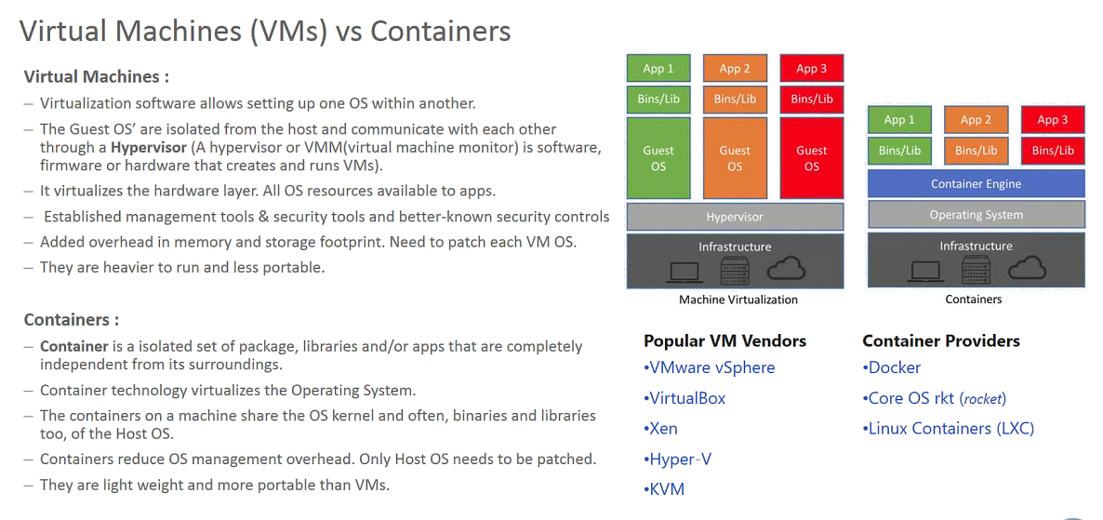

**Virtual Box is the vendor and vagrant are the software to create different VM.**

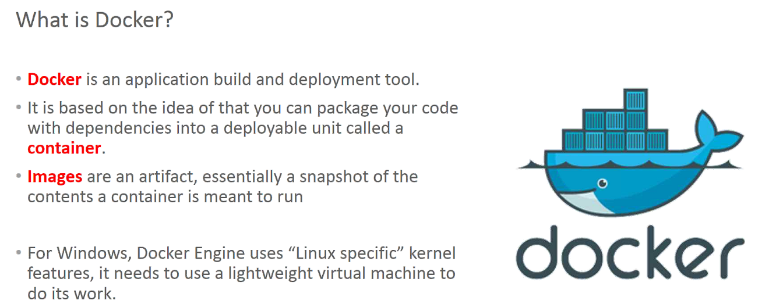

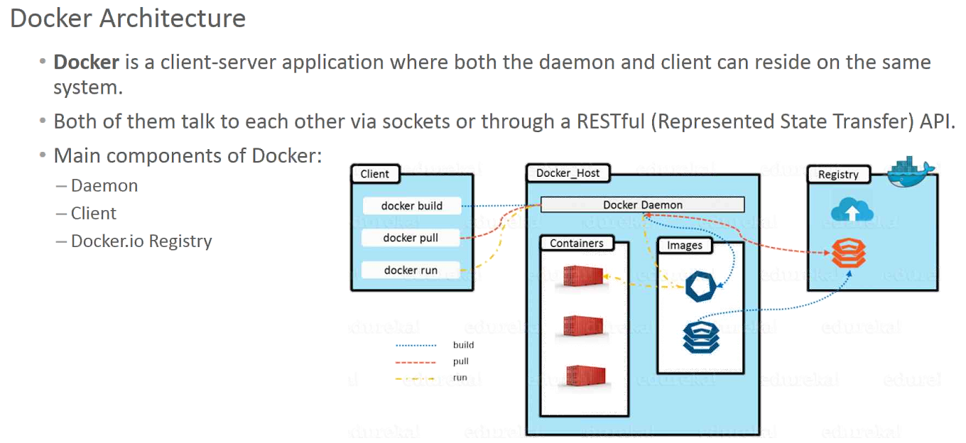

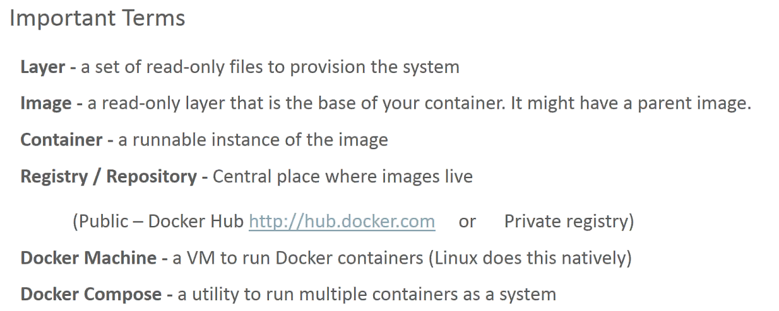

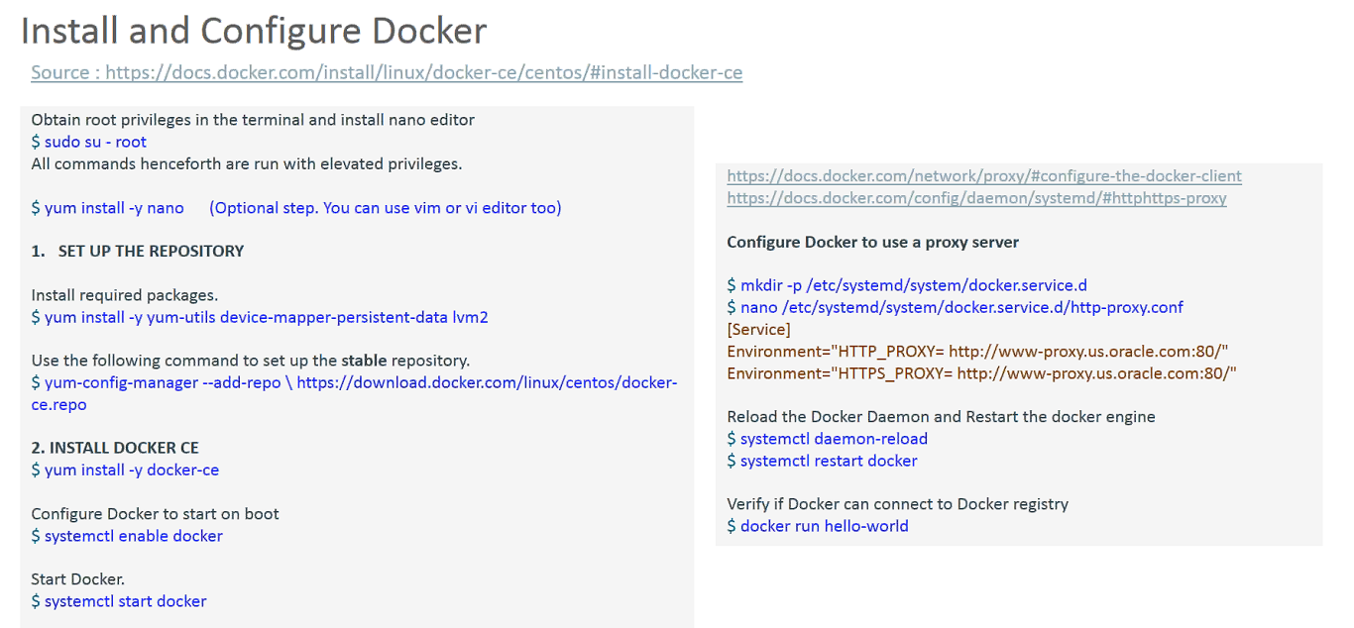

**Source:** [**https://docs.docker.com/install/linux/docker-ce/centos/#install-docker-ce**](https://docs.docker.com/install/linux/docker-ce/centos/#install-docker-ce)

**To install nano editor: pwd: /home/vagrant**

1. sudo su – root
2. whoami 🡪To check the current user
3. yum install -y nano 🡪 To download code editor
4. yum install -y yum-utils device-mapper-persistent-data lvm2

**To enable the system for docker usage these are prerequisite package**

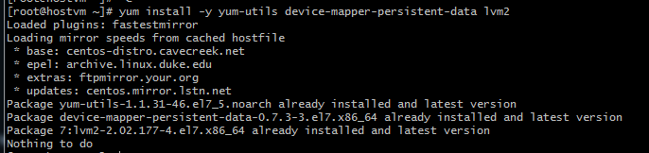

1. **yum-config-manager --add-repo** [**https://download.docker.com/linux/centos/docker-ce.repo**](https://download.docker.com/linux/centos/docker-ce.repo)

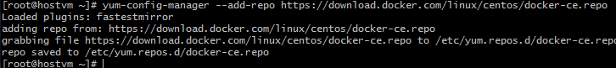

1. **To open using nano**

nano /etc/yum.repos.d/docker-ce.repo

CTRL+X for exit

1. **Installing Docker:**

yum install -y docker-ce

1. **Configure Docker to start on boot**

systemctl enable docker



1. To check the status of docker:

systemctl status docker

1. **To stop docker**

**Stop docker**

1. **To start docker:**

systemctl start docker

1. To check docker version:

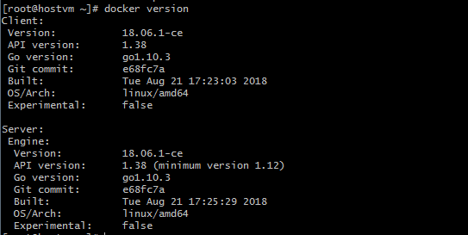

1. **Create an account in docker hub:**

[**https://hub.docker.com/**](https://hub.docker.com/)

**User Id:** b531628, **Password:** b531628

Email: Bishwajit.patel@oracle.com

2nd account: bispatel/bispatel

Email: bishwajit.patel@gmail.com

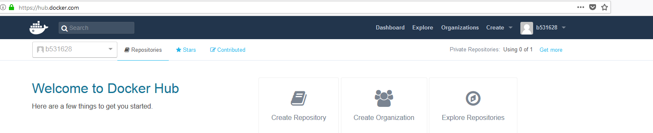

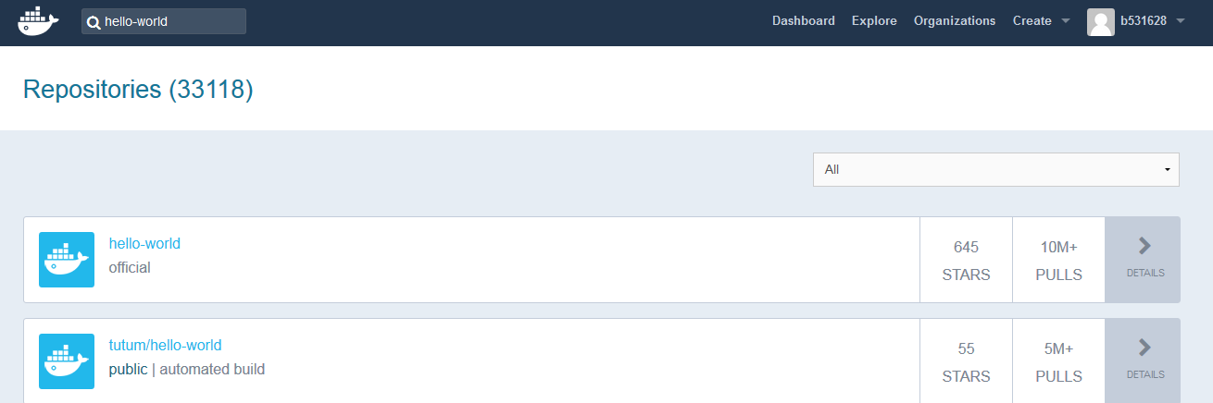

**In the terminal:**

docker search hello-world

1. Docker creates its owner internal network. So isolated layer can interact with internet using proxy

Setting up proxy for docker:

1. mkdir -p /etc/systemd/system/docker.service.d

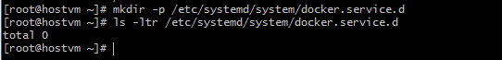

1. ls -ltr /etc/systemd/system/docker.service.d
2. To create config file:

vim /etc/systemd/system/docker.service.d/http-proxy.conf

Content of the file:

[Service]Environment="HTTP_PROXY=http://www-proxy.us.oracle.com:80/"Environment="HTTPS_PROXY=<http://www-proxy.us.oracle.com:80/>"

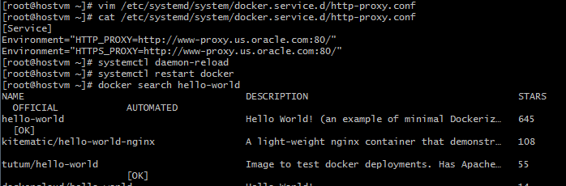

1. Reload docker so that proxy will be picked

systemctl daemon-reload

1. Restart Docker

systemctl restart docker

1. Seraching for a docker repository:

docker search hello-world

Official Image will have : image_name

Private Image: username/image_Name

1. Docker documentation:

<https://docs.docker.com>

1. To pull docker image from repository:

docker pull hello-world

1. To check all the images in docker:

docker images

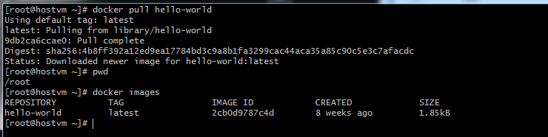

1. To check if any container is running or not

docker ps -a

1. To run image as acontainer

docker run hello-world

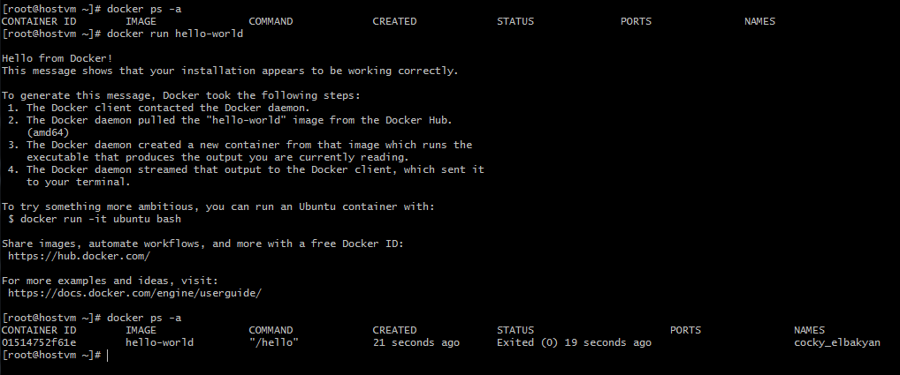

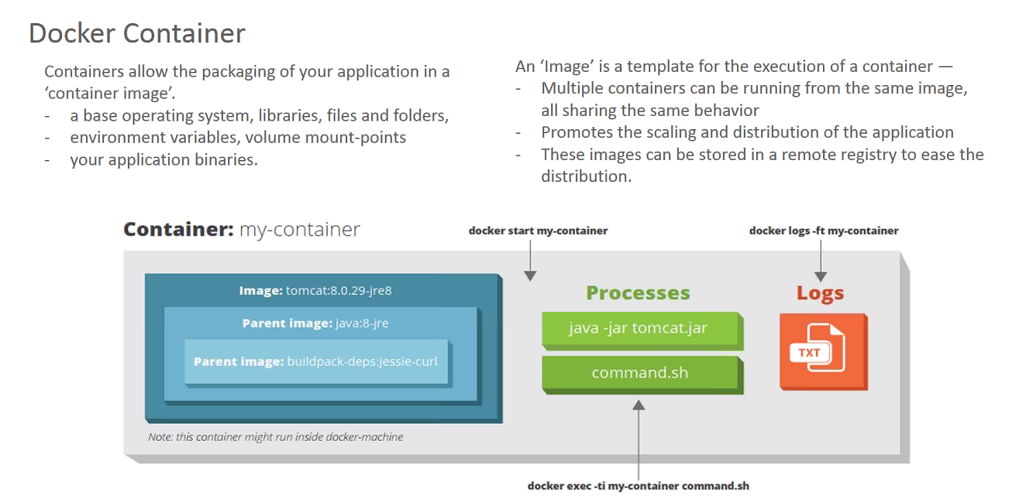

1. Online Utility to play with docker:

<https://labs.play-with-docker.com/>

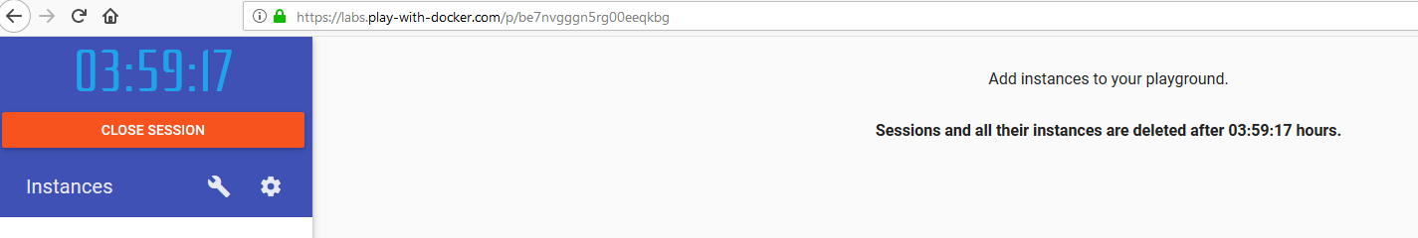

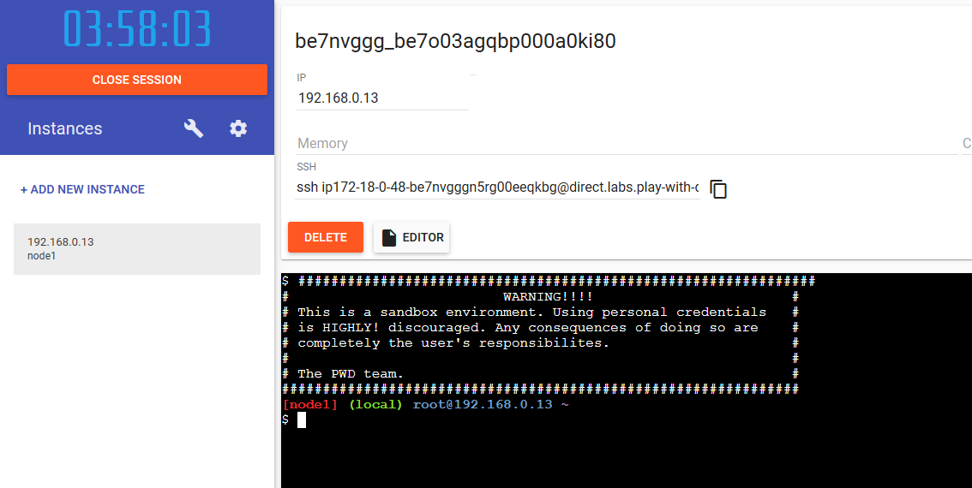

6th Sept:

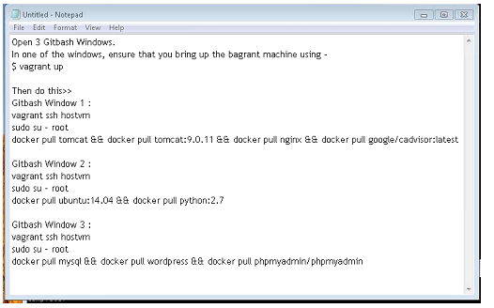

Execute in sudo user: sudo su – root

docker pull tomcat && docker pull tomcat:9.0.11 && docker pull nginx && docker pull google/cadvisor:latest

docker pull ubuntu:14.04 && docker pull python:2.7

docker pull mysql && docker pull wordpress && docker pull phpmyadmin/phpmyadmin

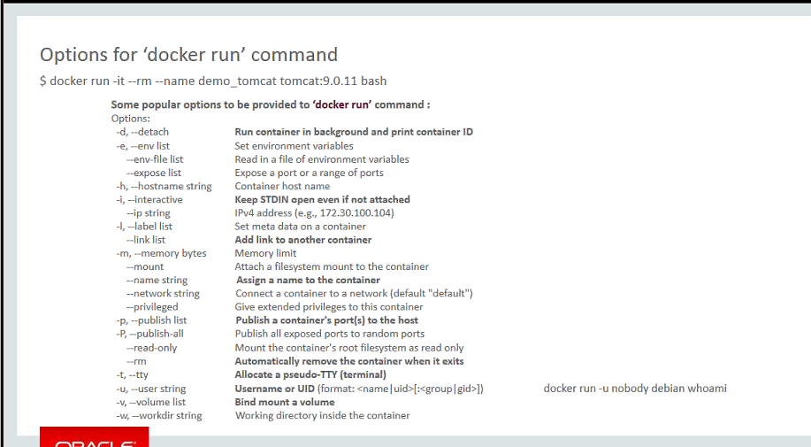

To start the container docker start eternal_tc

docker start “containerid”

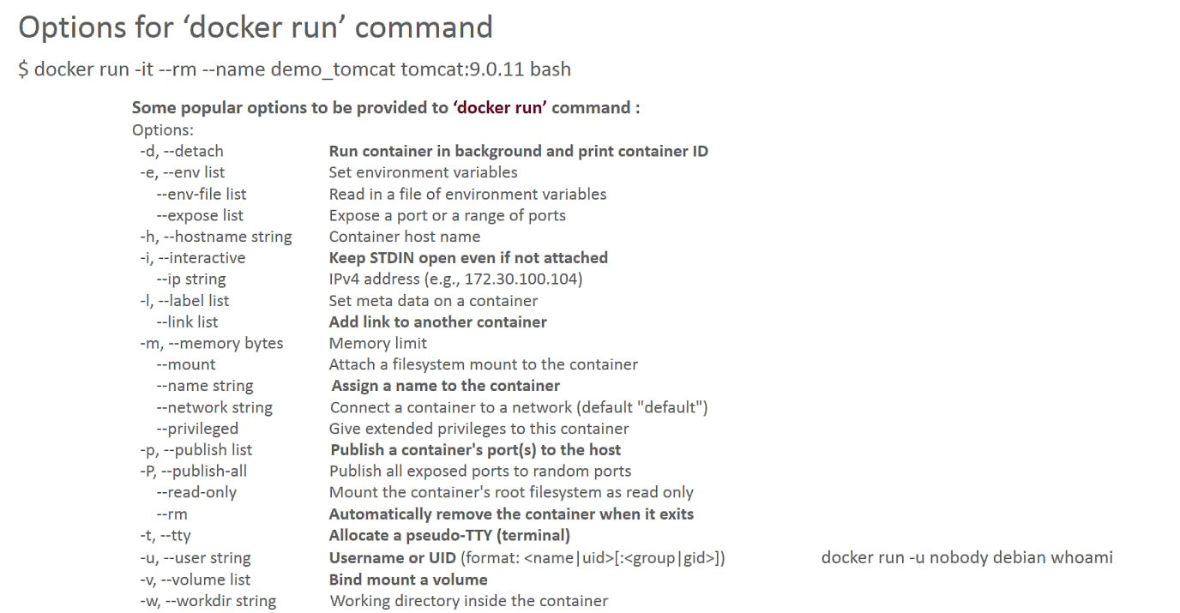

docker –help to checkall the run commands

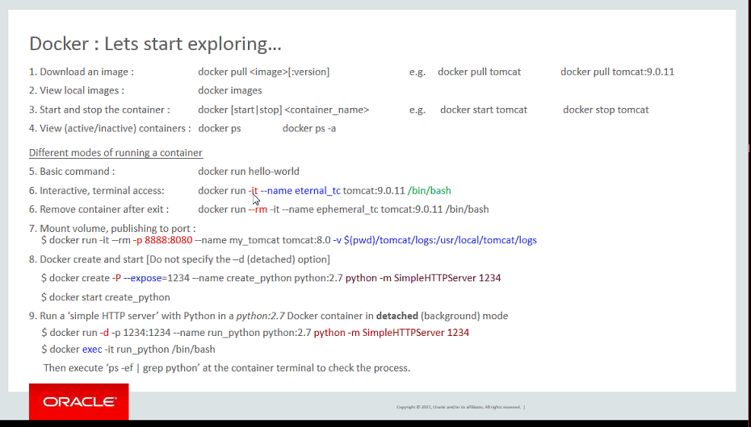

Point 7 is wrong:

docker run -it --rm -p 8888:8080 -v $(pwd)/tomcat/logs:/usr/local/tomcat/logs --name my_tomcat tomcat:9.0.11

To run the home page:

curl localhost:8888

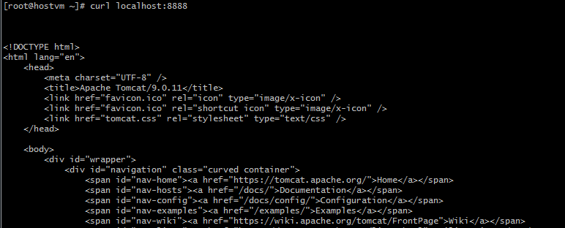

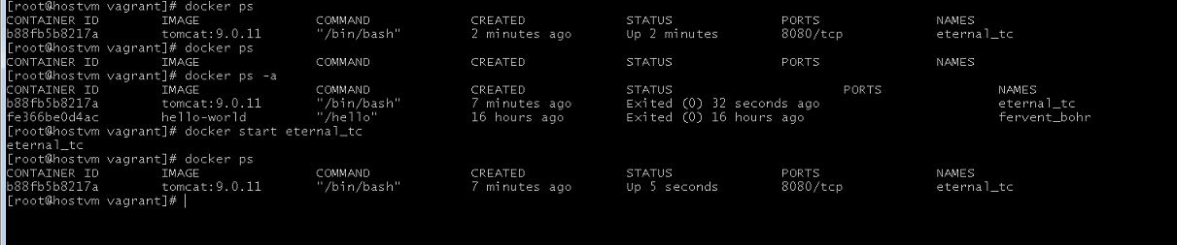

To check the ip of the machine:

Ifconfig

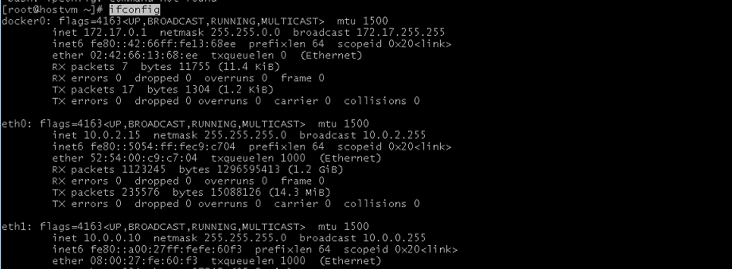

We can run it in the host machine using the ip:

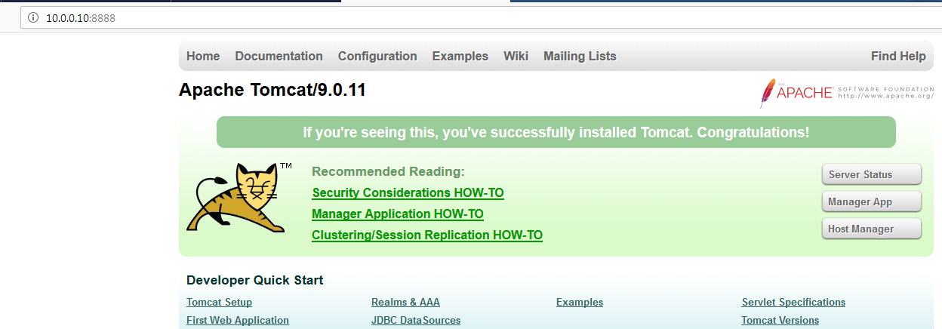

To run any container which is running in the background:

docker exec -it my_tomcat /bin/bash

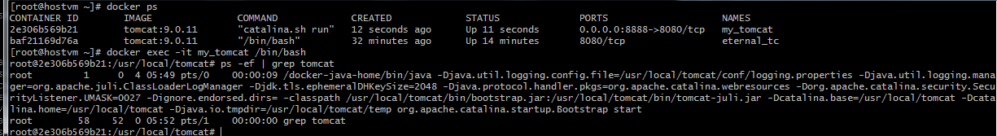

Ex:

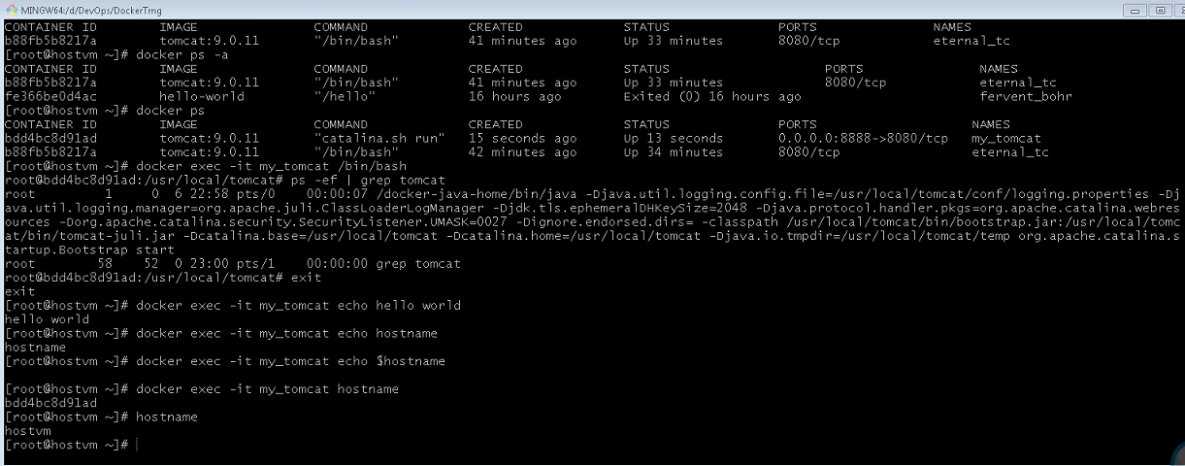

To check all the images:

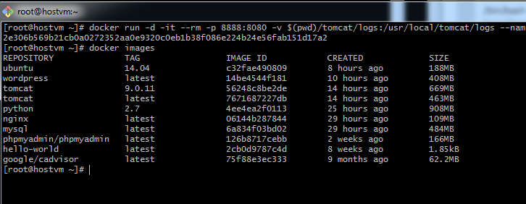

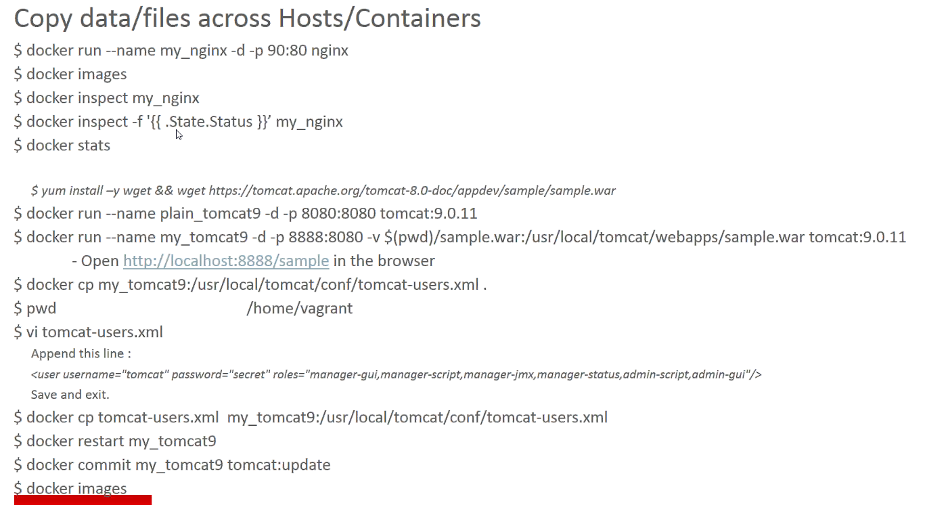

To run nginx web server:

1. Start nginx in 90 port in hostvm:

docker run --name my_nginx -d -p 90:80 nginx

1. docker inspect my_nginx

To check first 20 line : docker inspect my_nginx | head -20

1. To check the status of cpu :

docker stats

1. wget is for copying from internet and save in local directory

yum install –y wget && wget <https://tomcat.apache.org/tomcat-8.0-doc/appdev/sample/sample.war>

1. Running sample.war in tomcat:

docker run --name my_tomcat9 -d -p 9090:8080 -v $(pwd)/sample.war:/usr/local/tomcat/webapps/sample.war tomcat:9.0.11



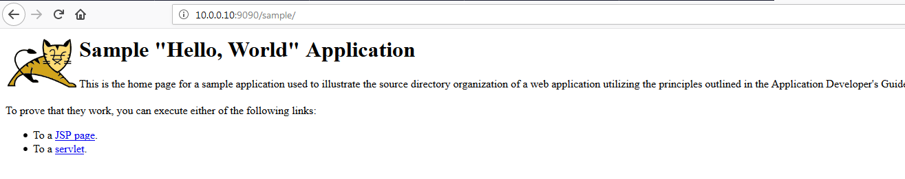

1. docker cp my_tomcat9:/usr/local/tomcat/conf/tomcat-users.xml .

copying the file

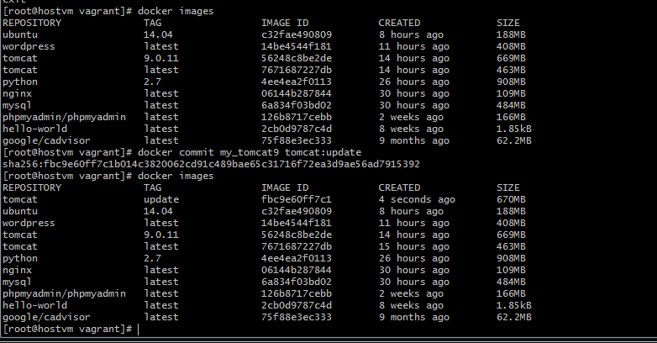

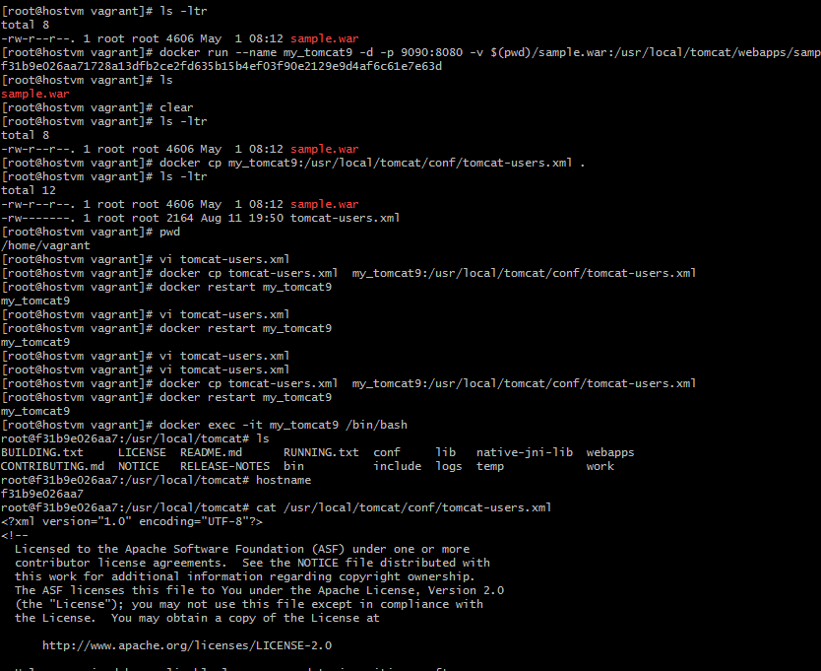

Changes to tomcat user xmla dn copy to container:

docker cp tomcat-users.xml my_tomcat9:/usr/local/tomcat/conf/tomcat-users.xml

Create the new Image with all the changes:

docker commit my_tomcat9 tomcat:update

Push the new Image

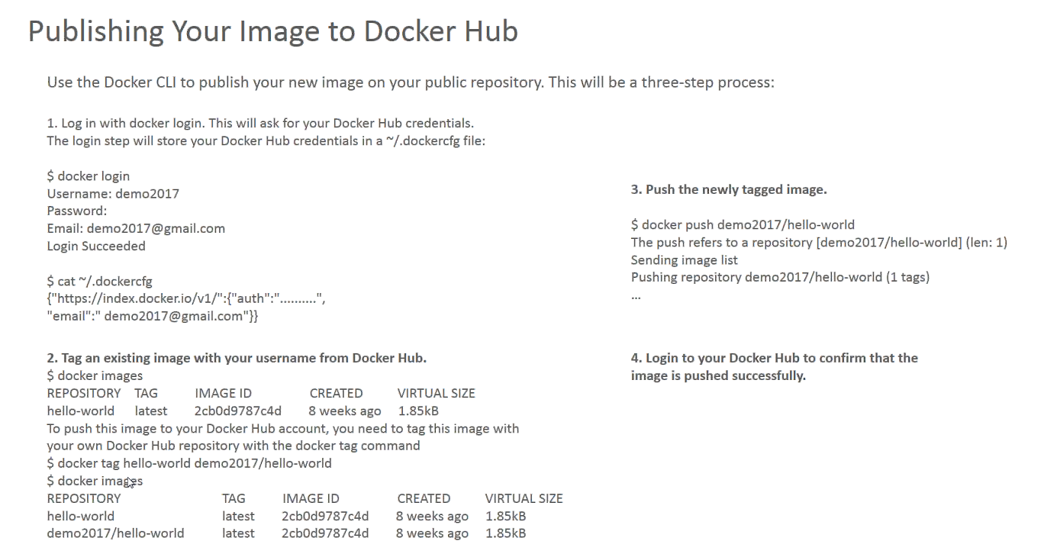

How to monitor the container in docker

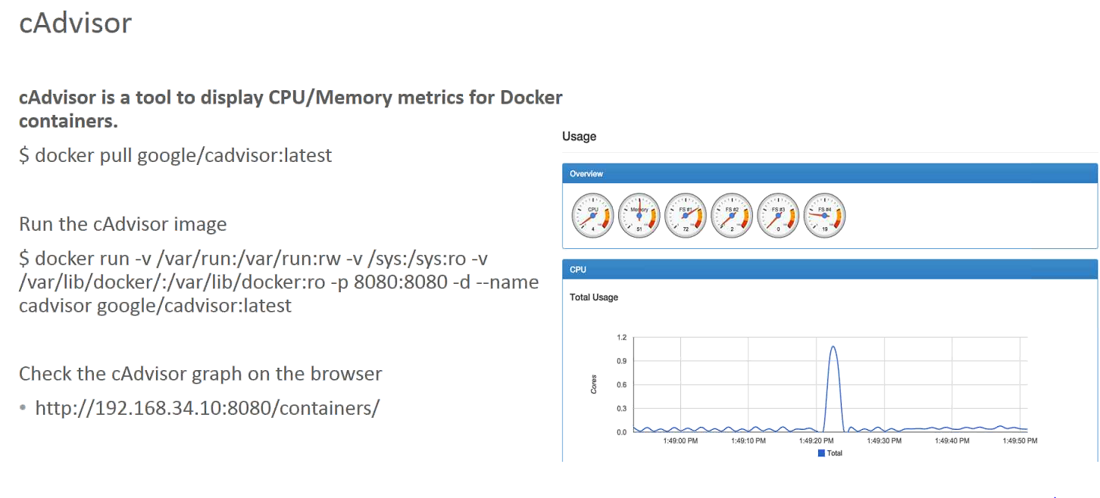

docker run -v /var/run:/var/run:rw -v /sys:/sys:ro -v /var/lib/docker/:/var/lib/docker:ro -p 9999:8080 -d --name cadvisor google/cadvisor:latest

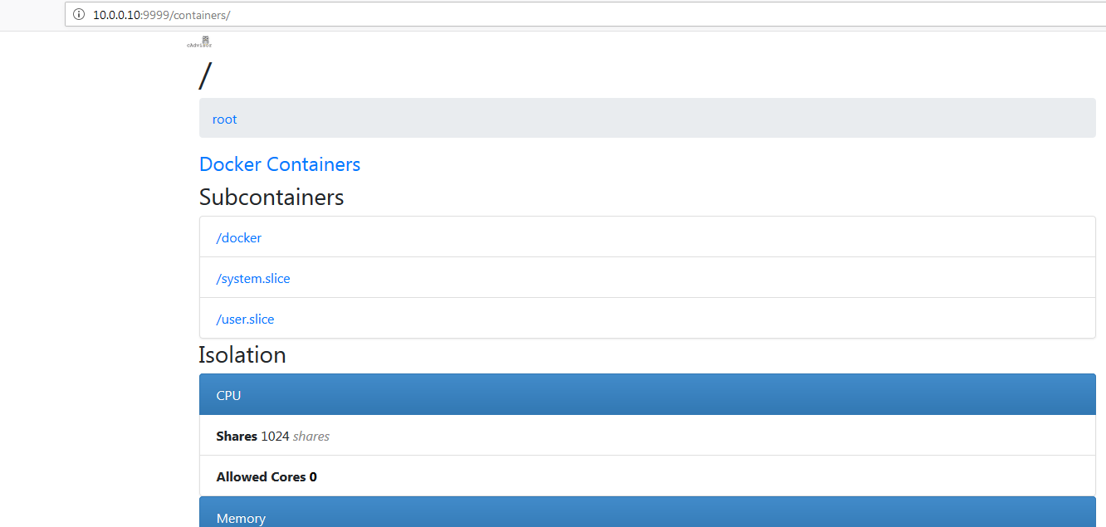

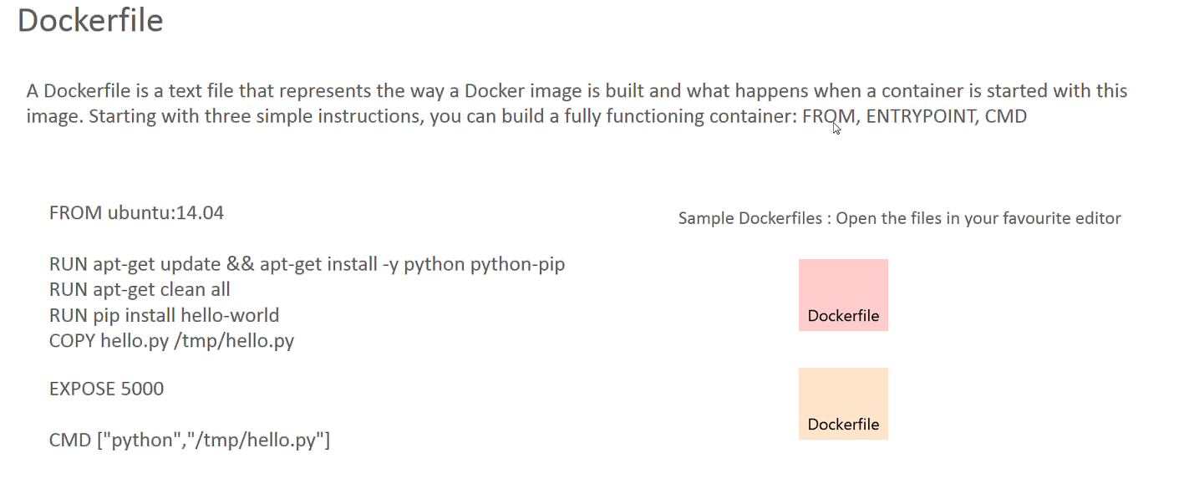

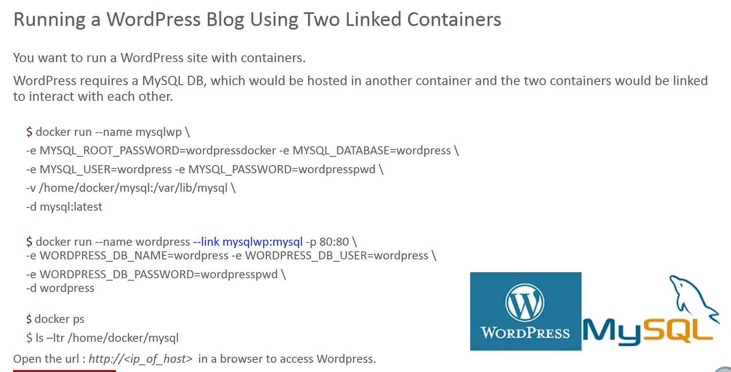

-e : Environment variable

docker run --name mysqlwp \-e MYSQL_ROOT_PASSWORD=wordpressdocker -e MYSQL_DATABASE=wordpress \-e MYSQL_USER=wordpress -e MYSQL_PASSWORD=wordpresspwd \-v /home/docker/mysql:/var/lib/mysql \-d mysql:latest

docker run --name wordpress --link mysqlwp:mysql -p 80:80 -e WORDPRESS_DB_NAME=wordpress -e WORDPRESS_DB_USER=wordpress -d wordpress

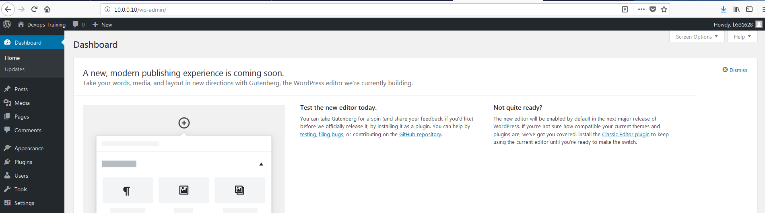

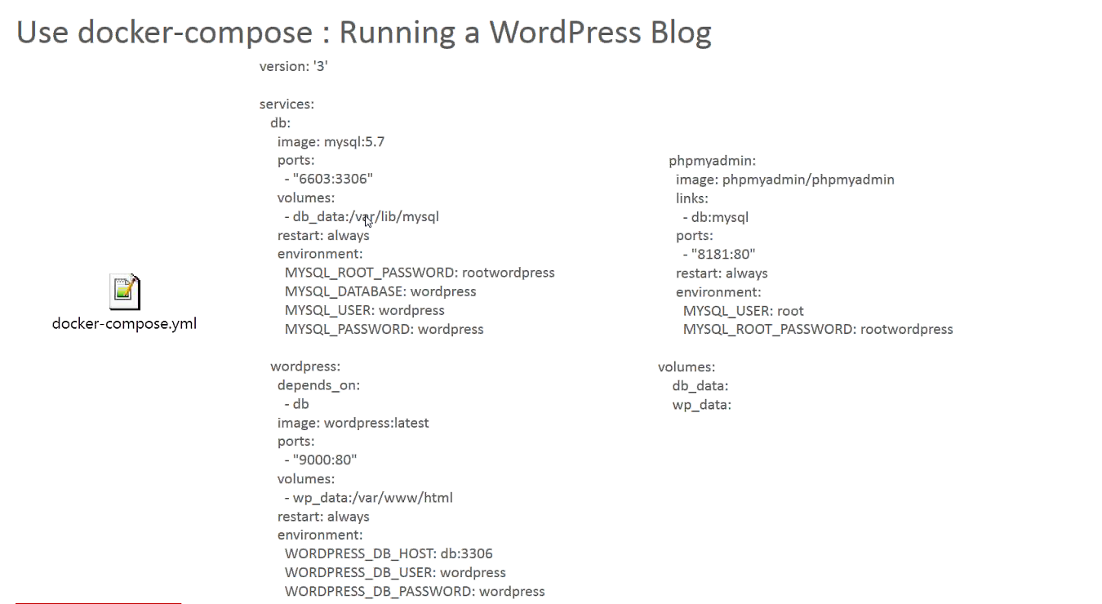

To download docker-compose:

<https://docs.docker.com/compose/install/#install-compose>

install:

sudo curl -L https://github.com/docker/compose/releases/download/1.22.0/docker-compose-$(uname -s)-$(uname -m) -o /usr/local/bin/docker-compose

